Introduction Outline
Paragraph1
Clams are an important ecological and economical species.
Clams are farmed in several countries around the world and account for a large proportion of total global production of shellfish.
Clams are sessile organisms with a planktonic larval period.
Clam larvae are sensitive to environmental stressors such as toxins, temperature, etc.

Paragraph 2
Ocean acidification as a result of anthropogenic carbon emissions is an immediate concern to the health of calcifying organisms.
Ocean acidification is a global problem that poses to impact shellfish harvests around the world. Recent reports of larval shellfish mortalities in Puget Sound are cause for concern and information regarding impacts on commercial shellfish larvae is needed.
Dissolved pCO2 concentrations can are controlled by several natural processes. Surface mixing is the interface where carbon dioxide from the atmosphere dissolves in seawater. Surface seawater that is equilibrated with atmospheric conditions can then be pulled down to the deep ocean where it incubates for several years under high pressure and low temperature. This water later resurfaces during upwelling events such as those documented off the western coast of the United States. Recent reports have observed pCO2 conditions that exceed 1000ppm in upwelled waters.
Carbonate chemistry in the intertidal region such as tide pools and sediments is extremely variable. Clam larvae settle in these environments and are consequently susceptible to changes in carbonate chemistry and potentially tolerable of wide fluctuations.

Paragraph 3
Advances in genomics, particularly transcriptomics, allows for the sequencing and documentation in transcriptional changes in organisms for which there is little genetic information in the form of sequence identification.
Genomics is a powerful too to observe functional changes in physiological processes impacted by changing environmental conditions.
Understanding the physiological response at the genetic level can provide valuable insight into mechanisms that either result in mortality or those that are used to tolerate stressful conditions.

Paragraph 4
Previous reports in clams have documented _________ thousand new contigs in clams, however these studies were down in a tissue specific manner on adult organisms. To date, no studies have looked at characterizing the transcriptome of larval clams and the genes involved in developmental processes.
No studies have used NGS to characterize the transcriptome of organisms exposed to different pCO2 levels. Several have used microarray technology, but microarrrays requre some previous knowledge of sequence information and are selective based on which contigs are representaed on the array.
NGS sequencing is an unbiased approach to charactrize the transcritpom.

Paragraph5
In this study we will characterize the transcriptome of larval clams and the genes that are activated during larval development.
We will also characterize changes between the transcriptome of clams exposed to ambient and future pCO2 concentrations.

Materials and Methods

Experimental Design
Needs some information on where the larvae came from, when/how they were spawned, how many families are represented in your larval populations, and at what point after spawning they were put in their treatments
Ruditapes philippinarum larvae were distributed to twelve plastic 4.5L containers with seawater (18ºC)at a density of approximately 48,600 larvae per container. Larval jars were then attached to recirculating seawater treatment systems at NOAA’s northwest fisheries science center in Seattle (For overview of system see _____). … that controlled water chemistry in two independent systems to maintain treatment conditions of 400ppm CO2 and 1000ppm CO2 with an average flow rate of 3L/hour. Larval clams were fed a mixture of nanno., CHAGRA, Iso, and Pavlova twice daily at a density of 50,000-80,000 cells/ml. On days 1, 4, 7, 11, and 14 three jars from each treatment were sampled for mortality and size measurements. From each container two larvae samples (~50 larvae) were taken by filtering larvae with a 50uM screen. Consecutive sampling of jars between sampling days was avoided to maintain similar larval densities between replicates. Samples for RNA extraction were taken on day 7 from two jars in each treatment by isolating larvae on a 50uM screen and transferring to a 1.5mL screw cap tube and freezing in liquid nitrogen. Larval samples for RNA extraction were stored at -80C.

Larval mortality and size analysis
Mortality was determined by counting the number of dead larvae in a petri dish using light microscopy, followed by counting all larvae following the addition of 75% ethanol. Larval size was determined by analyzing photographs taken at 5x magnification with a blah blah blah blah camera at 5x magnification. Total surface area for each larva was calculated using ImageJ.

RNA purification and sample preparation
RNA was extracted from approximately 30,000 larvae from each sample. A total of two samples were extracted for each treatment. RNA was isolated using Tri-reagent (Molecular Research Center, Inc.) following the manufacturers recommended protocol. Equal quantity of total RNA (20µg) from each replicate was pooled. Library construction and sequencing was performed at the University of Washington High Throughput Genomics Unit (UWHTGU) on the Illumina Hi-seq platform using standard Illumina protocols.

Illumina sequence data processing
Sequence data were analyzed using CLC Genomics Workbench version 4.0 (CLC bio). Sequences were trimmed based on a quality score limit of 0.05 (Phred; Ewing, Green, 1998; Ewing et al., 1998), no more than two ambiguous nucleotides, and a size limit of 25 bp. For gene discovery and RNA-seq analysis, sequences were first assembled together with other manila clam transcriptomic data in NCBI’s short read archive (SRA). This included sequences from digestive gland tissue (SRX022422 (Milan et al., 2011)) and gonad tissue (SRX076440-SRX076463 (Ghiselli et al., 2011)). De novo assembly parameters were as follows: limit=8, mismatch cost=2, and minimum contig size of 200 bp. Consensus sequences from de novo assembly were compared to the Swiss-Prot database (http://uniprot.org) to obtain putative sequence identification. Comparisons were made using the BLASTx algorithm with an e-value cutoff of 1e⁻³. Annotated sequences were paired with their associated GO terms (Gene Ontology database; http://www.geneontology.org) for characterization of genes based on biological processes and to group consensus sequences into parent terms (GO_slim).

MISSING: Section on Reference mapping reads back to combined, annotated contigs.

RNA-Seq analysis was carried out to determine differential gene expression patterns between the two libraries. The following parameters were used for analysis; unspecific match limit = 10, maximum number of mismatches = 2, minimum number of reads = 10. Expression values were measured in RPKM (reads per kilobase of exon model per million mapped reads, see [Mortazavi et al., 2008]). Differentially expressed genes were identified as having > 2 fold change in RPKM expression values and a significance of p<0.05.

Analysis of significantly enriched GO terms from differentially expressed genes was conducted using the Database for Annotation, Visualization, and Integrated Discovery (DAVID) v.6.7 (http://david.abcc.ncifcrf.gov/) (Nature Protocols 2009; 4(1):44 & Nucleic Acids Res. 2009;37(1):1). Contigs identified as differentially expressed by RNAseq analysis with a calculated e-vale of 1e⁻³ by BLASTx were used as a gene list while all contigs from the de novo assembly with e-vales no more than 1e⁻³ were used as the background. Significantly enriched GO terms were identified by Benjamini statistical analysis (p<0.05). Significantly enriched GO terms and their associated p-vales from DAVID were uploaded to REViGO (Reduce + Visualize Gene Ontology http://revigo.irb.hr/) for spatial visualization. Swiss-Prot accession numbers for significantly enriched GO terms were extracted for further analysis.

Results
Carbon Chemistry

Larval growth and survival

Illumina Sequencing and de novo assembly
176,019,837 reads were obtained from the 400ppm RNA library with an average length of 36 basepairs. 175,724,967 reads remained after trimming with an average length of 35.9.

68,062,722 reads were obtained from the 1000ppm mRNA library with an average length of 36 basepairs. 67,691,220 reads remained after trimming with an average length of 35.9

RNAseq analysis

References

Figure X
Summary of biological processes identified in larval clams by GO slim analysis
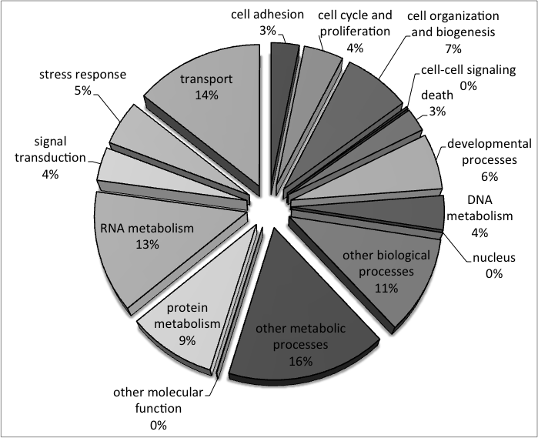

Figure X
Comparison of the biological process of genes up regulated by 2 fold or more based on RPKM values in larval clams exposed to 1000ppm and 400ppm.
